Beginner’s Photoshop for Photography

Creating a new document
Go: File-new-international paper – A4

Selecting and moving
- Using the move tool, drag my entire image into your new doc.
- Using rectangular marquee tool, select my head.
Using move tool, drag my head into new doc.
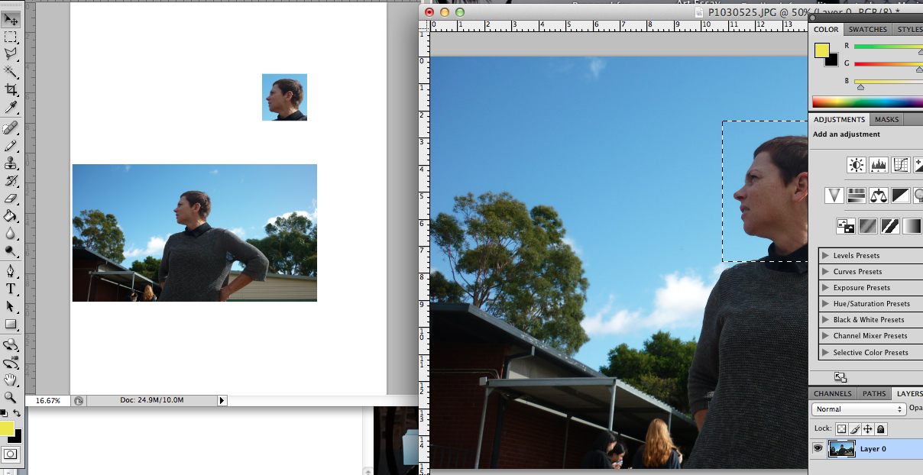

- Using the magic wand tool, select all the sky.
Select – inverse to select me instead of the sky
Using the move tool, drag me into the new doc

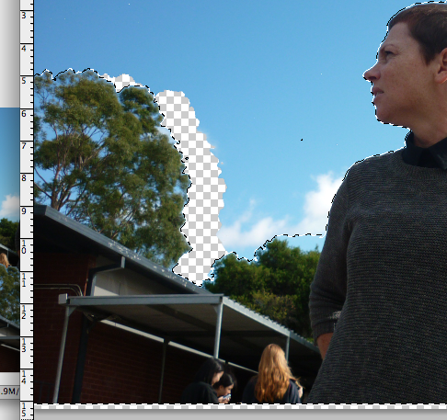

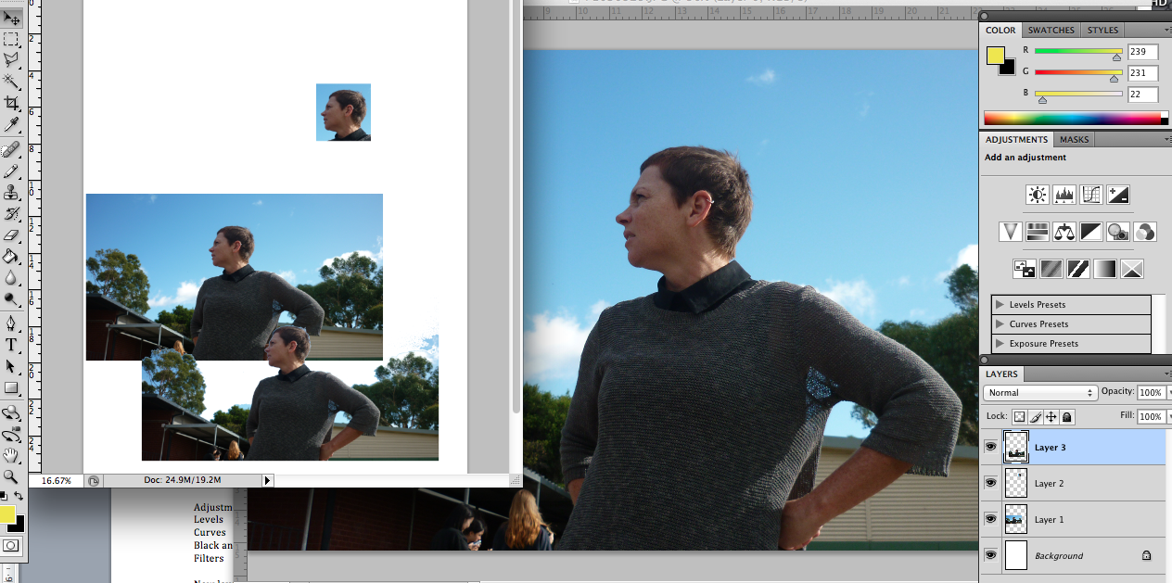

- To move things around in the new document, make sure you are using the move tool, and are working in the correct layer
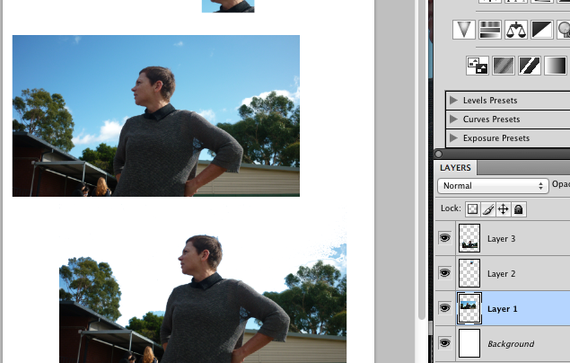

New layers
In your new document go layer – new fill layer – solid colour – ok
Make sure this layer is below the others in the layer palette
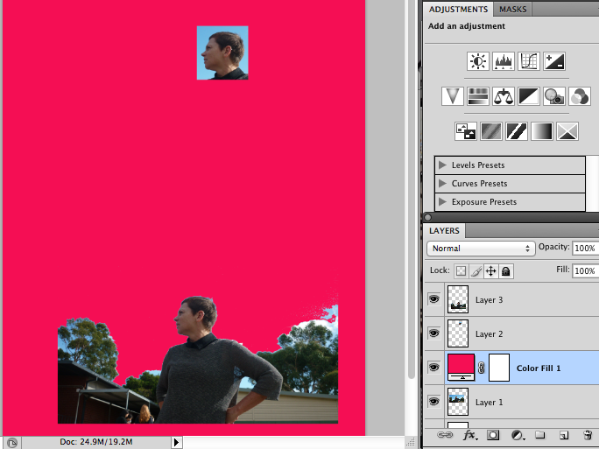

Layer Opacity

Select a layer, find the opacity button on the layers palette, reduce the opacity
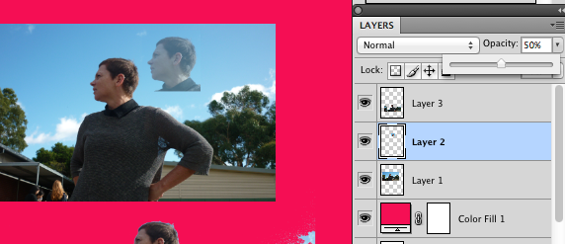

Cropping
Using the rectangular marquee tool in your original image, select the area you want to keep
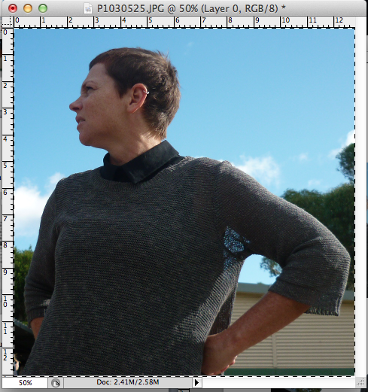
Go Image - crop

Adjustments
Go image – adjustments - levels and drag the sliders. See what kinds of effects you get.
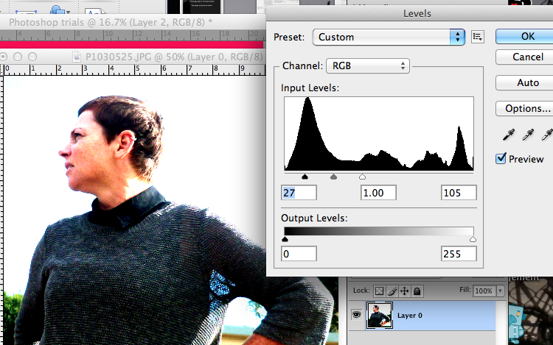

New adjustment layer
Now use the magic wand to select part of the image (eg sky)
Go layers – new adjustment layer –levels – select “Use previous layer to create clipping mask” - ok. Now play with the sliders again and see what happens.
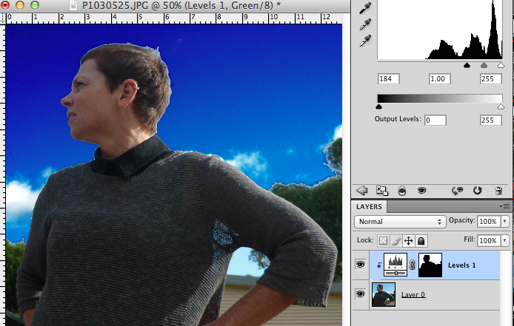

Test this out using curves, black and white and any other adjustments you fancy.

Take screengrabs of everything you do. Annotate what you do as you go so that you don’t forget.

